Rebuild server by cmd

Syntax

| openstack server --os-compute-api-version 2.95 \  rebuild Server_ID \  --image Image_ID \  --reimage-boot-volume |
| --- |

**Ví dụ:**

Xác định Server_ID

| openstack server list --project huydv_project |
| --- |

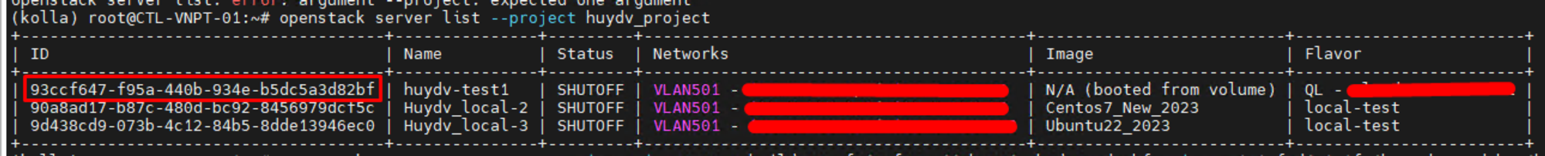

Xác định Image ID:

| openstack image list |
| --- |

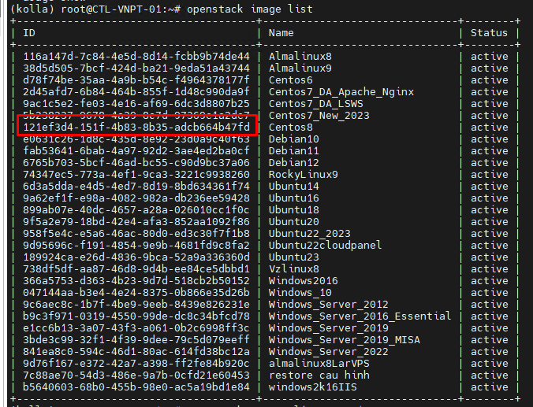

Lệnh rebiuld:

| openstack server --os-compute-api-version 2.95 \  rebuild 93ccf647-f95a-440b-934e-b5dc5a3d82bf \  --image 121ef3d4-151f-4b83-8b35-adcb664b47fd \  --reimage-boot-volume |
| --- |

